**The strength of sexual signals predicts same-sex paring in termites****.**

**Nobuaki Mizumoto**1,2,3#\***, Sang-Bin Lee**4#**, Thomas Chouvenc**4

1: Department of Entomology & Plant Pathology, Auburn, AL, USA

2: Evolutionary Genomics Unit, Okinawa Institute of Science & Technology Graduate University, Onna-son, Okinawa, 904-0495, Japan

3: Computational Neuroethology Unit, Okinawa Institute of Science & Technology Graduate University, Onna-son, Okinawa, 904-0495, Japan

4: Entomology and Nematology Department, Ft. Lauderdale Research and Education Center, Institute of Food and Agricultural Sciences, University of Florida, Ft. Lauderdale, FL 33314, USA

#: These authors contributed equally.

*: Correspondence: Nobuaki Mizumoto; [nzm0095@auburn.edu](mailto:nzm0095@auburn.edu)

ORCID: NM: 0000-0002-6731-8684; SBL: 0000-0001-7982-0842; TC: 0000-0003-3154-2489

**Abstract**

Same-sex sexual behavior (SSB) is an enigma in behavioral ecology as it does not result in reproduction. Proximately, the evolution of sexual signals is critical for the evolution of SSB in a sex-specific manner. For signal receivers, the loss of sexual signals leads to smaller sex differences, leading to frequent accidental SSB between receivers. Alternatively, for senders, sexual signals could help locate another sender, enhancing intentional SSB as in heterosexual pairing. Here, we demonstrate this link between sex pheromones and the frequency of same-sex pairing in two *Coptotermes* termites that use the same chemical as sex pheromones but in different quantities. In termites, mating pairs engage in tandem runs, where a male follows a female with sex pheromones. We found that female-female tandems were more frequently observed in *C. formosanus,* whose females produce more pheromones, while the male-male tandems were more observed in *C. gestroi*, whose females produce fewer pheromones. Thus, stronger pheromones lead to sender-sender SSB, while weaker pheromones lead to receiver-receiver SSB. In both species, same-sex tandems were less stable than heterosexual tandems, contrasting with the finding with *Reticulitermes*, another termite group that shows frequent same-sex tandems. The proximate mechanism of SSB is diverse, reflecting the heterosexual context.

**Keywords**: homosexual behavior, movement coordination, pheromone, same-sex sexual behavior, social insects

**Introduction**

Same-sex sexual behavior (SSB) is widespread among diverse animals with considerable variations across taxa [1–3]. In most species, the SSB is considered the result of mistaken identity [3,4], while in some cases, SSB provides adaptive value by making the best of a bad job with the shortage of heterosexual partners [5,6]. In either case, the occurrence of SSB is dependent on the mode of mating strategy in heterosexual contexts and strongly affected by the accuracy and carefulness of sex identification of the mating partner [7]. Sexual communication, mediated via sex-specific attracting signals (e.g., sex pheromones), underlies such sexual identification of the other sex. Therefore, even if the SSB does not have adaptive value, the evolutionary patterns of sexual signals could shape the diversity of SSB across species as a by-product. However, the role of sex-specific signals in SSB has remained unexplored.

As signal senders and receivers play different roles in mate pairing, the effect of sexual signals on SSB should differ between sender-sender and receiver-receiver pairs. For example, the strength of sexual signals has the opposite effect on the sender-sender SSB and receiver-receiver SSB. In species with weak sex-specific signals, more frequent SSB between receivers is expected compared with those with strong signals [8]. With small sexual differences, receivers can locate other receivers as well as senders, which may also provoke mistaken identity of the sex of the partner. On the other hand, more SSB between signal senders could be possible in the species with strong signals. It is rarer to observe SSB between senders as they are usually the passive sex during paring [9]. Nevertheless, with strong signals, it is easier for even senders to find other senders than other receivers. Thus, the strength of sexual signals is expected to modify the relative occurrence of receiver-receiver and sender-sender SSB across species.

Mate pairing in termites provides an ideal model system to study the evolution of SSB. Termites form life-long monogamous pairs to establish colonies [10]. During a brief period, alates (winged adults) disperse from their nests. Both females and males land on the ground or trees, shed their wings, and run to search for a mating partner. Upon joining, a pair performs a tandem run. In neoisopteran termites, the male always follows the female which produces sex pheromones [11], maintaining contact in a highly coordinated manner while seeking a suitable site for colony foundation. Although tandem running involves communication via sex pheromones, same-sex tandem running can be observed in either sex [11,12]. Sex pheromones should play different roles between female-female pairs and male-male pairs. In male-male pairs, same-sex tandem can happen once one male starts following another male. Thus, in the case of termite tandems, SSB can happen because of mistaken identity. This implies that species with weak sex pheromones may provoke male-male tandem pairingswhile female-female tandem should not happen because of mistaken identity. Conversely, in the case of strong pheromone signal, and as the sex role is fixed (females do not follow males) [11,13], female-female tandem runs may initiate after one female changes sex role in advance when not approached by males. In this situation, the sex pheromones of females instead facilitate same-sex tandems because females can easily follow another female.

In this study, we compared the same-sex tandem running behavior in two *Coptotermes* termites: *Coptotermes formosanus* Shiraki and *Coptotermes gestroi* (Wasmann). These two species share the same chemical for sex-pairing pheromones ((3Z,6Z,8E)-dodeca-3,6,8-trien-1-ol) produced by female tergal glands [14] and were previously observed forming heterosexual tandem runs [15,16]. However, the quantity of pheromones differs between these two species, where *C. formosanus* females produce ten times more pheromones than *C. gestroi* females [14]. Therefore, we here expect that male-male tandem should be more frequent in *C. gestroi* than *C. formosanus*, while female-female tandem should be more frequent in *C. formosanus* than *C. gestroi*. Finally, when a pair is separated during a heterosexual tandem run, sexual polyethism is displayed in both species, with females pausing to wait for males, while males move around to search for females. [17,18]. We therefore also investigated if an individual could display the typical behavior of the opposite sex in interrupted same-sex tandem runs.

**Methods**

*Termites and Experimental Arena*

We collected alates using a light-trapping system [ref] at dusk between 27-29 March for *C. gestroi* and 21-22 April, 1-2 May for *C. formosanus* in 2021 in Broward County (Florida, USA) during synchronized dispersal flights. All alates were collected at a single site. We brought the alates to the laboratory and maintained them on wet cardboard at 28°C. We used individuals who did not shed their wings by themselves to prevent any prior experience with tandem runs. After inducing shedding wings, we observed their behaviors within 12 h. Each individual was used only once.

We performed all observations in an experimental arena made of a Petri dish (ø = 150 mm) filled with moistened plaster. The Petri dish had a clear lid during observations. A video camera (HC-V770, Panasonic, Osaka, Japan above the arena was adjusted so that the arena filled the camera frame. We introduced a pair of termites into the arena. Each pair was recorded for 30 minutes in 30 frames per second (FPS). We obtained 49, 61, and 44 videos for female-male, female-female, and male-male in *C. formosanus*, and 40, 40, and 45 videos in *C. gestroi*. We extracted the coordinates of the centroids of termite movements from all obtained videos using the video-tracking system UMATracker [19]. We down-sampled all coordinates to a rate of five FPS for subsequent analyses. We measured the diameter of the dish and body length of two termites in pixels for each video using a Python program.

*Tandem analysis*

To compare the duration of tandem runs between pair combinations and species, we automatically determined that pairs were in tandem when the distance between their centroids was within the sum of their body length. This simplest threshold is used in a previous study [20], and using other complex definitions (e.g., [16–18]) did not change the conclusion. We did not count short interactions (< 5 seconds) as tandem runs and short separations (< 2 seconds) during tandem as interruptions.

To compare the duration of tandem runs between species and combinations, we used mixed-effects Cox models [coxme() function in the coxme package in R [21]], with pair combination (or species) treated as a fixed effect and each pair id as a random effect. We compared the durations between species for each combination (heterosexual, female–female, or male–male) and among combinations for each species separately. We also compared the proportion of the total time spent in tandem runs across different pairing combinations (or species). We transformed proportional data using logit transformation after adding 0.01 to the observed proportions to avoid infinite values [22]. We used the Welch t-tests to compare species for each pair combination, while one-way ANOVA with Tukey’s HSD to compare among combinations for each species. In the t-test and Tukey’s HSD, we obtained Cohen’s d value as effect sizes [cohens_d() function in the rstatix package in R]. Finally, for each separation event, we obtained the movement speed of both termites after 5 seconds of separation and calculated the absolute difference in movement speed. We compared the difference of movement speed using linear mixed-effects models [lmer() function in the lme4 package in R [23]], as the same approach with the mixed-effect Cox model as above.

All data analyses were performed using R v4.3.0 [24], and source codes are available on GitHub (https://github.com/nobuaki-mzmt/cop_homo_tandem_cf-vs-cg).

**Results**

The species difference in tandem running behavior depended on the pairing combinations. In heterosexual pairing, *C. formosanus* showed more stable tandems (mixed-effects Cox model, χ21 = 40.5, *P* < 0.001, Figure S1) and spent longer time for tandem runs than *C. gestroi* (t-test, *t*82.3 = 5.45, *P* < 0.001, *d* = 1.16, Figure 1). Note that this result contradicts a previous study that detected no significant difference between these two species [16], and this contradiction is discussed in the supplementary material (see Supplementary Text S1, Figure S2, and Table S1). A somewhat similar pattern was observed in female-female pairing, where *C. formosanus* showed more stable tandems than *C. gestroi* (mixed-effects Cox model, χ21 = 9.30, *P* = 0.002, Figure S1), without difference in the time spent in tandem runs (t-test, *t*83.6 = 1.62, *P* = 0.109, *d* = 0.33, Figure 1). On the other hand, male-male pairing showed the opposite pattern, where *C. gestroi* showed more stable tandems (mixed-effects Cox model, χ21 = 33.5, *P* < 0.001, Figure S1) and spent longer time for tandem runs than *C. formosanus* (t-test, *t*73.9 = 6.36, *P* < 0.001, *d* = 1.35, Figure 1). In either species, same-sex pairing was much more unstable than heterosexual pairing, with no difference between female-female pairs and male-male pairs in *C. gestroi* (comparison of time spent in tandem, TukeyHSD, FM-FF: *P* < 0.001, *d* = 1.72; FM-MM: *P* < 0.001, *d* = 2.05; FF-MM: *P* = 0.767, *d* = 0.181; Figure 1), while larger difference between female-female pairs and male-male pairs in *C. formosanus* (TukeyHSD, FM-FF: *P* < 0.001, *d* = 2.79; FM-MM: *P* < 0.001, *d* = 4.16; FF-MM: *P* < 0.001, *d* = 1.65; Figure 1).

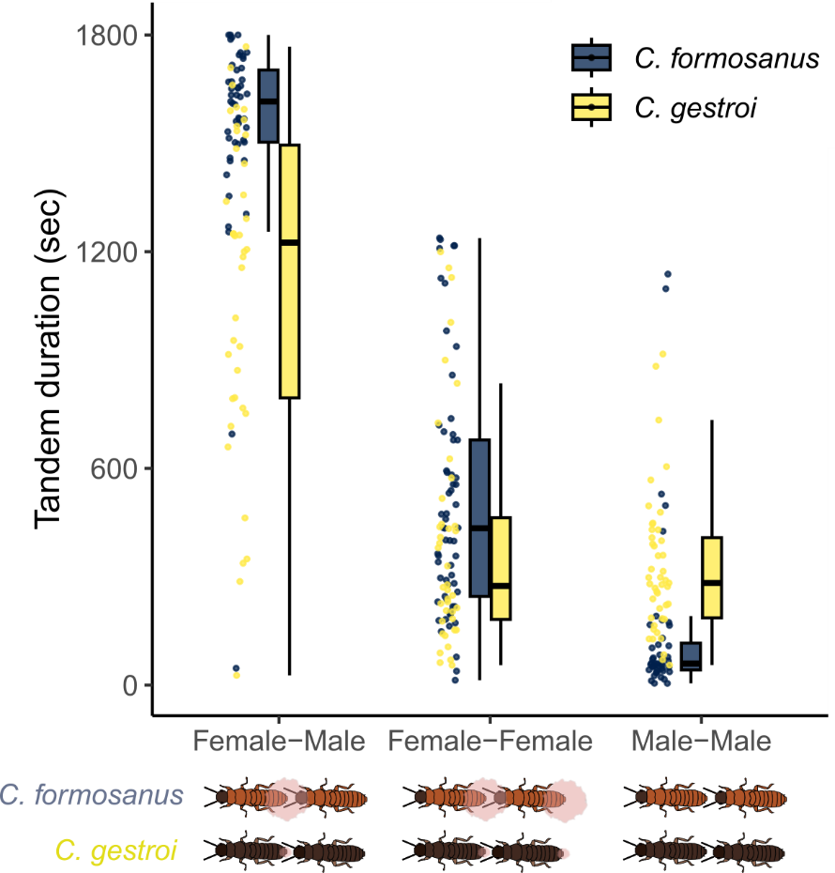

**Figure 1.** Comparison of the total time spent in tandem among pairing combinations and species. The sex-attracting pheromone is visualized below.

After separations, all combinations showed speed differences between partners. As shown in previous studies [17,18], in heterosexual pairs, male followers sped up while female leaders slowed down after separation to enhance the probability of reunions (Figure 2). Similar movement differences between partners were observed in same-sex pairings (Figure 2). However, the levels of difference between partners were smaller in same-sex pairing, compared with heterosexual pairs both in *C. formosanus* (LMM, χ22 = 55.9, *P* < 0.001; Tukey’s HSD, FM-FF: *z* = 6.77, *P* < 0.001; FM-FF: *z* = 6.49, *P* < 0.001; FM-FF: *z* = 0.573, *P* = 0.834) and *C. gestroi* (LMM, χ22 = 28.0, *P* < 0.001; Tukey’s HSD, FM-FF: *z* = 4.18, *P* < 0.001; FM-FF: *z* = 4.98, *P* < 0.001; FM-FF: *z* = 0.71, *P* = 0.757).

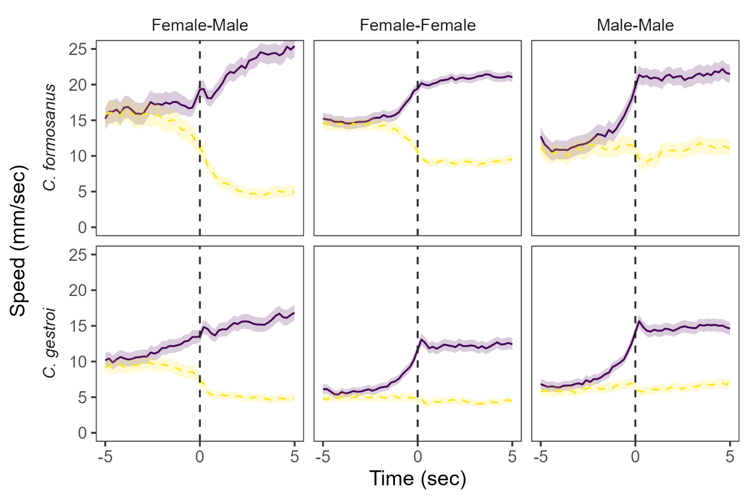

**Figure 2.** Movement speed of termites before and after separation (t = 0). Separation timing was determined when the distances between partners were larger than the sum of their body lengths. Solid lines indicate a partner moved faster, while dashed lines slower. Lines and shaded regions indicate mean ± 95% confidence intervals..

**Discussion**

We found an association between same-sex pairing behavior and sex pheromone quantity in two termite species with shared chemicals. First, female-female pairing was more stable in *C. formosanus*, the species with more sex pheromones. Because females are leaders in *Coptotermes* tandem, females need to decide to play follower roles before the initiation of same-sex pairing [11], where females could use sex pheromones to maintain stable movement coordination with same-sex individuals. On the other hand, male-male pairing was more frequent in *C. gestroi*, the species with a smaller quantity of sex pheromones. Male-male tandem runs of these species could be by mistaken identity, where *C. gestroi* more frequently misidentified the partner’s sex due to smaller sexual dimorphism. Either way, our study clearly demonstrated that the evolution of SSB in termites is inseparable from the evolution of sex-attracting signals.

Previous studies on same-sex tandem runs in termites have focused only on *Reticulitermes* termites [11,12,25,26]. In *Reticulitermes* termites, same-sex pairing functions by providing survival benefits [5,12,27] and is not a result of mistaken identity [11]. However, a distinct pattern observed in *Coptotermes* termites suggests that same-sex tandem in *Coptotermes* termites is not a functional behavior but rather a behavior expressed outside of its original function. In *Reticulitermes* termites, same-sex tandem pairs were as stable as heterosexual tandem pairs, and one partner behaves like the other sex upon separation [11]. In *Coptotermes* termites, on the other hand, even once they form a same-sex tandem pair, both female-female and male-male tandems were far less stable than heterosexual tandems (Figure 1, S1). Moving speed was also slower in same-sex tandems than in heterosexual pairs (Figure 2). Furthermore, upon separation, movement dimorphisms between partners, a key for efficient reunion, were not as strong as heterosexual pairs (Fig. 2). These all indicate that *Coptotermes* termites do not tend to adjust their movement patterns to maintain same-sex tandems actively. The same-sex tandems in *Coptotermes* termites could exist due to the ancestral state of termite tandem running behavior [11], as in the framework of the previous work [4].

Even though the same-sex pairing of *Coptotermes* termites is not adaptive, our study on their interspecific variations shows the mechanical aspects of the evolution of SSB. For example, a previous theoretical study predicted that SSB is caused by the absence of perfect sex discrimination, where the loss of sexual signals and indiscriminate mating coevolve together [28]. Our result supports this idea by showing that the species with weaker sexual signals showed more frequent same-sex pairing than the other. In other words, *C. gestroi* has a broader mating filter than *C. formosanus* and tries to pair with non-female individuals, as shown in a cricket [29], a burying beetle [30], and a water strider [31]. Furthermore, although all of the previous studies have considered the SSB between individuals of signal-receiving sex (typically males) [4,7,28], our results also indicated that the evolution of sexual signals could also affect the evolution of SSB between signal-sending sex (typically females), where stronger signals might attract same-sex individuals and lead to sender-sender SSB. This newly suggested relationship needs further empirical tests in other animal lineages, possibly in the context of available partner density.

In summary, our study highlights the diversity of SSB that can exist even within a closely related species. By connecting mating behavior in heterosexual contexts with the occurrence of SSB across species, comparative behavioral analysis has the potential to answer the questions relating to the evolution of SSB.

**Data accessibility**

All data and source codes for analyzing them are available at Github: <https://github.com/nobuaki-mzmt/cop_homo_tandem_cf-vs-cg>., and the accepted version will be deposited at Zenodo.

**Authors’ contributions**

NM: Conceptualization, Methodology, Formal analysis, Data curation, Writing – original draft

SBL: Methodology, Investigation, Data curation, Writing – review & editing

TC: Resources, Writing – review & editing

**Competing interests**

The authors declare no competing interest.

**Acknowledgments**

We thank Aoi Mizumoto for assistance during the video analysis. This work was supported by a JSPS Research Fellowships for Young Scientists CPD, to NM (20J00660), a Grant-in-Aid for Early-Career Scientists (21K15168) to NM, and an IPSF fellowship from OIST to N.M.

**References**

1. Bagemihl B. 1999 *Biological exuberance: Animal homosexuality and natural diversity*. New York: NY: St. Martins’ Press.

2. Bailey NW, Zuk M. 2009 Same-sex sexual behavior and evolution. *Trends in Ecology & Evolution* **24**, 439–446. (doi:10.1016/j.tree.2009.03.014)

3. Scharf I, Martin OY. 2013 Same-sex sexual behavior in insects and arachnids: prevalence, causes, and consequences. *Behavioral Ecology and Sociobiology* **67**, 1719–1730. (doi:10.1007/s00265-013-1610-x)

4. Monk JD, Giglio E, Kamath A, Lambert MR, McDonough CE. 2019 An alternative hypothesis for the evolution of same-sex sexual behaviour in animals. *Nature Ecology and Evolution* **3**, 1622–1631. (doi:10.1038/s41559-019-1019-7)

5. Mizumoto N, Yashiro T, Matsuura K. 2016 Male same-sex pairing as an adaptive strategy for future reproduction in termites. *Animal Behaviour* **119**, 179–187. (doi:10.1016/j.anbehav.2016.07.007)

6. Young LC, VanderWerf EA. 2013 Adaptive value of same-sex pairing in Laysan albatross. *Proceedings of the Royal Society B: Biological Sciences* **281**. (doi:10.1098/rspb.2013.2473)

7. Lerch BA, Servedio MR. 2021 Same-sex sexual behaviour and selection for indiscriminate mating. *Nature Ecology and Evolution* **5**, 135–141. (doi:10.1038/s41559-020-01331-w)

8. Pfau D, Jordan CL, Breedlove SM. 2021 The de-scent of sexuality: Did loss of a pheromone signaling protein permit the evolution of same-sex sexual behavior in primates? *Archives of Sexual Behavior* **50**, 2267–2276. (doi:10.1007/s10508-018-1377-2)

9. Burgevin L, Friberg U, Maklakov AA. 2013 Intersexual correlation for same-sex sexual behaviour in an insect. *Animal Behaviour* **85**, 759–762. (doi:10.1016/j.anbehav.2013.01.017)

10. Nutting WL. 1969 8 Flight and colony foundation. In *Biology of termites* (eds K Krishna, FM Weesner), pp. 233–282. New York: Academic Press. (doi:10.1016/B978-0-12-395529-6.50012-X)

11. Mizumoto N, Bourguignon T, Bailey NW. 2022 Ancestral sex-role plasticity facilitates the evolution of same-sex sexual behavior. *Proceedings of the National Academy of Sciences of the United States of America* **119**, e2212401119. (doi:10.1073/pnas.2212401119)

12. Matsuura K, Kuno E, Nishida T. 2002 Homosexual tandem running as selfish herd in *Reticulitermes speratus*: novel antipredatory behavior in termites. *Journal of theoretical biology* **214**, 63–70. (doi:https://doi.org/10.1101/2022.06.20.496918)

13. Park YI, Bland JM, Raina AK. 2004 Factors affecting post-flight behavior in primary reproductives of the Formosan subterranean termite, *Coptotermes formosanus* (Isoptera: Rhinotermitidae). *Journal of Insect Physiology* **50**, 539–546. (doi:10.1016/j.jinsphys.2004.03.010)

14. Chouvenc T, Sillam-Dussès D, Robert A. 2020 Courtship behavior confusion in two subterranean termite species that evolved in allopatry (Blattodea, Rhinotermitidae, *Coptotermes*). *Journal of Chemical Ecology* , 1–14. (doi:10.1007/s10886-020-01178-2)

15. Chouvenc T, Helmick EE, Su N-Y. 2015 Hybridization of two major termite invaders as a consequence of human activity. *PLoS ONE* **10**, e0120745. (doi:10.1371/journal.pone.0120745)

16. Mizumoto N, Lee SB, Valentini G, Chouvenc T, Pratt SC. 2021 Coordination of movement via complementary interactions of leaders and followers in termite mating pairs. *Proceedings of the Royal Society B: Biological Sciences* **288**, 20210998. (doi:10.1098/rspb.2021.0998)

17. Mizumoto N, Dobata S. 2019 Adaptive switch to sexually dimorphic movements by partner-seeking termites. *Science Advances* **5**, eaau6108. (doi:10.1126/sciadv.aau6108)

18. Mizumoto N, Rizo A, Pratt SC, Chouvenc T. 2020 Termite males enhance mating encounters by changing speed according to density. *Journal of Animal Ecology* **89**, 2542–2552. (doi:10.1111/1365-2656.13320)

19. Yamanaka O, Takeuchi R. 2018 UMATracker: An intuitive image-based tracking platform. *Journal of Experimental Biology* **221**, 1–24. (doi:10.1242/jeb.182469)

20. Valentini G, Mizumoto N, Pratt SC, Pavlic TP, Walker SI. 2020 Revealing the structure of information flows discriminates similar animal social behaviors. *eLife* **9**, e55395. (doi:10.7554/eLife.55395)

21. Therneau TM. 2015 coxme: mixed effects Cox models.

22. Warton DI, Hui FKC. 2011 The arcsine is asinine: The analysis of proportions in ecology. *Ecology* **92**, 3–10. (doi:10.1890/10-0340.1)

23. Bates D, Mächler M, Bolker BM, Walker SC. 2015 Fitting linear mixed-effects models using lme4. *Journal of Statistical Software* **67**. (doi:10.18637/jss.v067.i01)

24. R Core Team. 2023 R: A language and environment for statistical computing.

25. Li G, Zou X, Lei C, Huang Q. 2013 Antipredator behavior produced by heterosexual and homosexual tandem running in the termite *Reticulitermes chinensis* (Isoptera: Rhinotermitidae). *Sociobiology* **60**, 198–203. (doi:DOI: 10.13102/sociobiology.v60i2.198-203)

26. Wu J, Wang J, Wang Y, Hassan A. 2023 Same-sex Pairs Retain Their Reproductive Capacity as a Potential Opportunity for Individual Reproductive Success in Termites. *Journal of Insect Science* **23**, 9. (doi:10.1093/jisesa/ieac073)

27. Matsuura K, Fujimoto M, Goka K. 2004 Sexual and asexual colony foundation and the mechanism of facultative parthenogenesis in the termite *Reticulitermes speratus* (Isoptera, Rhinotermitidae). *Insectes Sociaux* **51**, 325–332. (doi:10.1007/s00040-004-0746-0)

28. Lerch BA, Servedio MR. 2023 Indiscriminate Mating and the Coevolution of Sex Discrimination and Sexual Signals. *The American Naturalist* **201**, E56–E69. (doi:10.1086/723213)

29. Richardson J, Zuk M. 2023 Rethinking same-sex sexual behaviour: male field crickets have broad mating filters. *Proc. R. Soc. B.* **290**, 20230002. (doi:10.1098/rspb.2023.0002)

30. Engel KC, Männer L, Ayasse M, Steiger S. 2015 Acceptance threshold theory can explain occurrence of homosexual behaviour. *Biology letters* **11**, 20140603. (doi:10.1098/rsbl.2014.0603)

31. Han CS, Brooks RC. 2015 Same-sex sexual behaviour as a by-product of reproductive strategy under male–male scramble competition. *Animal Behaviour* **108**, 193–197. (doi:10.1016/j.anbehav.2015.07.035)

32. Chouvenc T, Scheffrahn RH, Mullins AJ, Su N-Y. 2017 Flight phenology of two *Coptotermes* species (Isoptera: Rhinotermitidae) in southeastern Florida. *Journal of Economic Entomology* **56**, 291–312. (doi:10.1093/jee/tox136)

Supplementary material for

**The strength of sexual signals predicts same-sex paring in termites**

**Nobuaki Mizumoto, Sang-Bin Lee, Thomas Chouvenc**

*. Author correspondence: [nzm0095@auburn.edu](mailto:nzm0095@auburn.edu)

This file includes:

Text S1

Figure S1-2

Table S1

**Supporting Information Text**

**Text S1. Comparison of heterosexual tandems across experimental years.**

In this study, we detected the clear difference in stability and time spent of heterosexual tandem running behavior between *C. formosanus* and *C. gestroi* (Figure 1, S1). However, this result is contradicting with the previous study that found a similar level of tandem stability between these two species (see Figure 1 of [16]). To investigate the source of this inconsistency, we reanalyzed the data of previous studies using *C. formosanus* and *C. gestroi* in this region [16,18] using the exact same methodology with this study. We have three different datasets, one obtained in 2019 only for *C. gestroi* to investigate their density-dependent behavioral change, one obtained in 2020 for both species to investigate the heterospecific tandem runs, and one obtained in 2021 for both species in this study (Table S1).

In *C. formosanus*, there was no difference between this study and a previous study in the duration of each tandem run (mixed-effects Cox model, χ21 = 0.557, *P* = 0.456; Figure S2A) and total time spent in tandem runs (t-test, *t*21.3 = 0.969, *P* = 0.344, *d* = 0.277; Figure S2B). On the other hand, in *C. gestroi*, we found different stabilities of tandem runs across studies, where results obtained in 2020 showed marginally higher duration of tandem runs compared to others (mixed-effects Cox model, χ22 = 6.207, *P* = 0.045; Tukey’s HSD, 2020-2019: *z* = -2.16, *P* = 0.075, 2021-2019: *z* = 0.483, *P* = 0.876, 2021-2020: *z* = 2.48, *P* = 0.034; Figure S2A). Note that the total time spent in tandem runs was not different among studies (ANOVA, *F*2 = 1.15, *P* = 0.322; 2020-2019: *d* = -0.521, 2021-2019: *d* = -0.060, 2021-2020: *d* = 0.515; Figure S2B). When we compared the tandem running behavior between two *Coptotermes* termites by accounting for the experimental years as a random effect, *C. formosanus* showed higher stability (mixed-effects Cox model, χ21 = 51.3, *P* < 0.001, Figure S2A) and longer period of tandem runs than *C. gestroi* (linear mixed-effects model, χ21 = 38.2, *P* < 0.001, Figure S2B). Thus, tandem running stability is actually different between *C. gestroi* and *C. formosanus*, but Mizumoto et al., 2021 [16] failed in detecting it probability due to the smaller sample size (Table S1).

In *C. gestroi*, why did experiment in 2020 show higher stability of tandem runs compared to 2019 and 2021, even the difference is small? This experiment focused on the interspecific tandem runs between *C. gestroi* and *C. formosanus*, thus, they observed their tandem runs on the date when both species swarmed together, which needs to be the very end of the swarming season of *C. gestroi* [15] (Table S1). As physiological conditions of termite alates can change across the swarming seasons in both *C. gestroi* and *C. formosanus* [32], this variability of swarming season might have changed their tandem running behavior, too. Further studies need to clarify this hypothesis.

**Figure S1.** Comparison of the duration of tandem running until separation across different pairing combinations and species. Kaplan–Meier survival curves were generated for each pairing combination. The marks for censored data are not shown. Shaded regions show 95% confidence intervals.

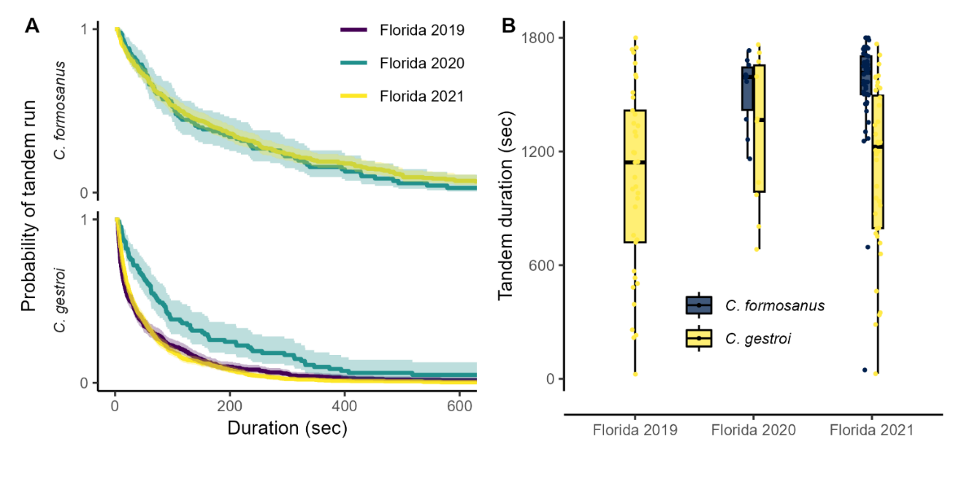

**Figure S2.** Comparison of tandem running behavior in heterosexual pairs across different experiments in (A) the duration of tandem running until separation and in (B) total time spent in tandem during 30-minute observation. Data from Florida 2019 is from Mizumoto et al., 2020 [18], from Florida 2020 is from Mizumoto et al., 2021 [16], and Florida 2021 is from this study. (A) Kaplan–Meier survival curves were generated for each pairing combination. The marks for censored data are not shown. Shaded regions show 95% confidence intervals.

**Table S1**. Comparison of experimental conditions across studies.

|  |  |  |  |  |  |  |  |
| --- | --- | --- | --- | --- | --- | --- | --- |
| Species | Experiments | Date | Tandems | Pairs | Temp | Arena | Ref |
| *C. gestroi* | Florida 2019 | March 5,8 | 484 | 37 | 28 | 140 | [18] |
| ***C. gestroi*** | **Florida 2020** | **April 18,20** | **89** | **10** | **28** | **140** | **[16]** |
| *C. gestroi* | Florida 2021 | March 27-29 | 721 | 40 | 28 | 150 | This study |
| *C. formosanus* | Florida 2020 | April 18,20 | 94 | 10 | 28 | 140 | [16] |
| *C. formosanus* | Florida 2021 | April 21-22,  May 1-2 | 421 | 49 | 28 | 150 | This study |

Tandems: the number of tandem running events used for survival analysis (Figure S2). Arena indicates the size of arena in mm.